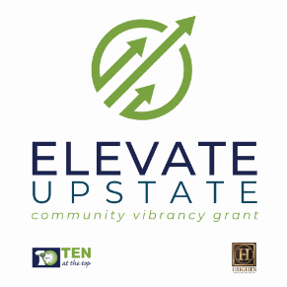
2025 Elevate Upstate Initial Interest Form
We ask that the 2025 Elevate Upstate Grant Initial Interest Form be completed and submitted via email to info@tenatthetop.org by August 15, 2025. This form illustrates an interest in being considered for the full grant and will help Ten at the Top gauge overall interest for the 2025 cycle. Submitting this initial interest form does not replace the full application or that an organization cannot alter their project before submitting the final application. You will receive confirmation of receipt of your interest form.

Name of Organization:
Name of Contact:
Contact Email:
Contact Phone Number:
Organization’s Mailing Address:
Project Title:
Brief Project Description:
(in 5 sentences or less)

Complete applications for the 2025 Elevate Upstate Community Vibrancy Grant are
due September 12, 2025.

